|  |  |  |  |
| --- | --- | --- | --- |
| Grifo UA preto | **Universidade de Aveiro**  **Ano 2017** | Departamento de Eletrónica,  Telecomunicações e Informática | |
| **Tomás Marques Rodrigues** | **End-user quality of service and experience in mobile networks**  Qualidade de serviço e experiência em redes móveis na ótica do utilizador final | | |
|  |  | | |
|  |  | |  |

|  |  |  |  |
| --- | --- | --- | --- |
| Grifo UA preto | **Universidade de Aveiro**  **Ano 2017** | Departamento de Eletrónica,  Telecomunicações e Informática | |
| **Tomás Marques Rodrigues** | **End-user quality of service and experience in mobile networks**  Qualidade de serviço e de experiência em redes móveis na ótica do utilizador final | | |
|  | Tese apresentada à Universidade de Aveiro para cumprimento dos requisitos necessários à obtenção do grau de Mestre em Engenharia de Computadores e Telemática, realizada sob a orientação científica do Doutor João Paulo Silva Barraca, Professor assistente convidado do Departamento de Eletrónica, Telecomunicações e Informática da Universidade de Aveiro. | | |
|  |  | |  |

|  |  |
| --- | --- |
|  |  |
| o júri |  |
| presidente | Doutora Maria do Rosário Gonçalves dos Reis Marques Domingues  Professora Associada com Agregação do Departamento de Química da Universidade de Aveiro |
|  |  |
|  | Doutora Teresa Margarida dos Santos  Professora Auxiliar do Departamento de Química da Universidade de Aveiro |
|  |  |
|  | Doutora Susana Isabel Fonseca de Almeida Santos Braga  Equiparada a Investigadora Principal do Departamento de Química da Universidade de Aveiro |
|  |  |
|  |  |
|  |  |

|  |  |
| --- | --- |
|  |  |
|  |  |
|  |  |
|  |  |

|  |  |
| --- | --- |
|  |  |
|  |  |

|  |  |
| --- | --- |
| agradecimentos | Aos meus orientadores, …  A XXX. Obrigada pela forma xxx como me acolheram e me integraram no vosso grupo de trabalho. Foi uma ótima ajuda para que tudo corresse pelo melhor.  A XXX. Obrigada pela forma xxx como me acolheram e me integraram no vosso grupo de trabalho. Foi uma ótima ajuda para que tudo corresse pelo melhor.  Aos meus pais e à minha irmã o maior agradecimento. Para vos agradecer tudo o que já fizeram por mim eu precisava de uma tese inteira e não apenas de uma secção nos agradecimentos, vocês foram o meu pilar ao longo destes anos. Obrigado por terem sempre acreditado em mim e por me ajudarem a conseguir fazer sempre mais e melhor. Obrigada por me mostrarem que não interessam as notas ou os graus que eu consiga, que aquilo que interessa é eu seguir o meu sonho e ser feliz. Obrigada por todos os sacrifícios que já fizeram por mim. Obrigada por não me deixarem sentir mal mesmo quando as coisas correm menos bem. Obrigada por estarem sempre presentes. Muito, muito obrigado, sem vocês isto nunca teria sido possível.  A todos os meus amigos, por toda a disponibilidade e por me apoiarem nas minhas derrotas e por festejarem comigo as minhas vitórias. |

|  |  |
| --- | --- |
|  |  |
|  |  |
| palavras-chave | Qualidade de serviço, qualidade de experiência, redes móveis, aplicação móvel, android SDK, 4G, LTE |
| resumo | Os operadores de redes móveis recorrem a equipamentos dedicados (sondas) para obtenção de métricas relativas ao desempenho, QoS e QoE das suas redes e serviços. Pretende-se desenvolver uma app Android com funcionalidades de probing, não só complementando os equipamentos dedicados na recolha de informação relativa ao desempenho, QoS e QoE, como também detetando problemas ao nível da rede e dos seus serviços automaticamente no próprio terminal do cliente final, como também disponibilizando ferramentas de teste ao cliente e ao suporte para uma maior celeridade na resolução de problemas. |

|  |  |
| --- | --- |
|  |  |

|  |  |
| --- | --- |
|  |  |
| keywords | Quality of service, quality of experience, mobile networks, mobile app, android SDK, 4G, LTE |
| abstract | Mobile network operators use dedicated equipment (probes) to obtain performance, QoS and QoE metrics for their networks and services. It is intended to develop an Android App with probing features, not only complementing the dedicated equipment in the collection of information regarding performance, QoS and QoE, but also detecting problems at the network and its services automatically in the final client terminal and providing customer test tools and support for faster troubleshooting. |
|  |  |

Contents

List of figures x

List of tables xi

List of Snippets xii

List of acronyms xiii

**I**ntroduction 19

1.1 Motivation 19

1.2 Objectives 20

1.3 Contributions 21

1.4 Project Structure 21

State of Art 22

2.1 Mobile Network Evolution 22

2.2 Quality of Service 32

2.3 Quality of Experience 34

2.4 Study of Market 34

2.5 VoIP 35

2.5.1 VoLTE 36

2.5.2 VoWiFi 37

2.6 Audio Quality 38

2.7 Android 38

2.6.1 Android History 39

2.6.2 Root/Jailbreak 41

2.6.3 System apps vs. Non-System app 43

2.6.3 Comparing Video Quality 43

ArQoS Pocket solution 45

3.1 Overview and Objectives 45

3.2 Use cases 45

3.3 Requirements 46

3.4 ArQoS Pocket Solution Architecture 46

Developed Work 47

4.1 Tests 47

4.1.1 Intrusive Tests 47

4.2.1 Passive Tests 47

Results and Discussion 52

Conclusions and Future Work 54

References 55

Appendix A 59

Appendix B 62

# List of figures

Figure 1- FDMA based on AMPS 1G technology [5] 23

Figure 2 - GSM architecture 24

Figure 3 - GPRS architecture 25

Figure 4 - Legacy Telecom Model and 3GPP Telecom Model respectively 26

Figure 5 - 3GPP IMS architectural overview 27

Figure 6 - 3G architecture model [10] 28

Figure 7 - Mobile technology evolution [5] 29

Figure 8 - 2020+ experience 30

Figure 12 - Grant access to READ_LOGS via shell command 47

Figure 13 - Call logcat in runtime 47

# List of tables

Table 1- Evolution of wireless technologies xxii

# List of Snippets

Snippet 1 - Logfile - Information about user location 45

Snippet 2 - Logfile - open a specific application 46

Snippet 3 - Logfile - Sanitized information 46

# List of acronyms

3

**3G –** Third generation mobile networks

**3GPP –** 3rd Generation Partnership Project

4

**4G –** Fourth generation of [wireless](https://en.wikipedia.org/wiki/Wireless) [mobile telecommunications](https://en.wikipedia.org/wiki/Mobile_telephony) technology

5

**5G –** Fifth generation mobile networks (not yet standardized)

A

**APN –** Access Point Name **AuC –** Authentication Center

**AMPS –** Advance Mobile Phone Service

B

**BSC –** Base Station Controller

**BSS –** Base Station Subsystem

**BTS –** Base Transceiver Station

**BSSID –** Basic Service Set Identifier

C

**CO2 –** [Carbon Dioxide](http://www.thefreedictionary.com/Carbon+Dioxide)

**C-RAN –** Cloud Radio Access Network

**CDMA –** Code Division Multiple Access

**CEPT –** European Conference of Postal and Telecommunications Administrations

**CSFB –**  Circuit Switched Fallback

**CAPEX –** Capital Expenditure

D

**DL –** Downlink

**DVB –** Digital Video Broadcasting

**DMTF –** Dual Tone – Multi Frequency

E

**EIR –** Equipment Identity Register

**EDGE –** Enhanced Data rate for GSM Evolution

**ETSI –** European Telecommunications Standards Institute

**EUTRAN –** Evolved Universal Terrestrial Radio Access Network

G

**GSM –** Global System for Mobile Communications

**GGSN –** Gateway GPRS Support Node

**GSMA –** Global System for Mobile Communications Association

**GPRS –** General Packet Radio Service

H

**HLR** – Home Location Register

**HTTP** – [Hypertext Transfer Protocol](https://pt.wikipedia.org/wiki/Hypertext_Transfer_Protocol)

**HSPA+ –** Evolved High-Speed Packet Access

**HSCSD –** High Speed Circuit Switched Data

**HSDPA** – High-Speed Downlink Packet Access

**HSUPA –** High-Speed Uplink Packet Access

I

**IP –** Internet Protocol

**IMS –** IP Multimedia Service

**IoT –** Internet of Things

**ISP** **–** Internet Service Provide

**ICMP** **–** Internet Control Message Protocol

**IEEE –** Institute of Electrical and Electronics Engineers

**IMEI –** International Mobile Equipment Identity

**IPv4** **–** Internet Protocol version 4

**IMAP4 –** Internet Message Access Protocol

L

**LTE –** Long Term Evolution

M

**ME –** Mobile Equipment

**MS –** Mobile Station

**MAC –** Media Access Control

**MMS –** Multimedia Messaging Service

**MOS –** Mean Opinion Score

**MSC –** Mobile Switching Center

**Mbps –** Megabits per second

**MIMO –** Multiple Input Multiple Output

N

**NFC –** Near Field Communication

**NMT –** Nordic Mobile Telephone

**NSS –** Network Switching Subsystem

O

**OS –** Operating System

**OTA –** Over the Air

**OTT –** Over the Top

**OPEX –** Operational Expenditure

P

**P2P –** Peer-to-Peer

**PCU –** Packet Controller Unit

**PIN –** Personal Identification Number

**PESQ –** Perceptual Evaluation of Speech Quality

**POP3 –** Post Office Protocol

**PSTN –** Public Switched Telephone Network

**POLQA –** Perceptual Objective Listening Quality Assessment

Q

**QoE –** Quality of experience

**QoS –** Quality of service

R

**RF –** Radio frequency

**RNC –** Radio Network Controller

**RNS –** Radio Network Subsystem

**ROM –** Read Only Memory

**RUU –** ROM Update Utility

S

**SAE –** System Architecture Evolution

**SS7 –** Signaling System No. 7

**SIM –** Subscriber Identity Module

**SGSN –** Serving GPRS Support Node

**SMTP** **–** Simple Mail Transfer Protocol

**SSID –** Service Set Identifier

T

**TACS –** Total Access Communication System

U

**UL –** Uplink

**UMTS –** Universal Mobile Telecommunications System

V

**VLR –** Visitor Location Register

**VoIP –** Voice over IP (Internet Protocol)

**VoLTE –** Voice over LTE

W

**WAP –** Wireless Application Protocol

**WCDMA –** Wideband Code Division Multiple Access

**Wi-Fi –** Wireless Fidelity

**WLAN –** Wireless Local Area Network

**WMAN –** Wireless Metropolitan Area Network

**WPAN –** Wireless Personal Area Network

Chapter **1**

# **I**ntroduction

Human relationships are based on communication and the technology is changing to improve the way we interact with each other. In telecommunications we evolved from analogical services to the digital, including not only voice, but also data services to 4G with better debits and capacity and lower latency. The requirement for higher data speed on smartphones is increasing rapidly, much due to the usage of social networks and other entertainment data in these small devices. Constant improvement in wireless data rate is already happening and different network technologies are integrated to provide seamless connectivity and are transparent to user, making the network appear heterogeneous despite the complexity involved.

User’s expectations are always growing with new services appearing constantly and the quality of service needs to be in a constant improvement in order to follow this technological evolution. Although the internet was designed to provide services without quality guarantees, in case of operators they are contractually obliged to guarantee certain quality in some services provided by them and working to clients that more and more want to be always connected and with mobility. This leads to a lot of work had to be done to grant quality, performance and a good user experience.

## Motivation

Technology is, more and more, part of the daily life of the human being and according to GSMA data the number of mobile connections already surpassed the number of people on earth and it’s growing five times faster [1]. Humanity communicates on a global scale thanks to the increasing development of mobile devices technology. Computing and communication had lead to a notorious evolution of mobile devices, which have become not only a mean of communication, but also a way of accessing extensive functionalities. The broadband speed let us view videos with high resolution or take photos everywhere becoming this small device that fits in a pocket the communication and entertainment tool of today’s election.

The rapid growth of wireless communications allowed the rising number of small devices like smartphones and tablets connected together in the network, faster, in real-time and longer with the improvements in batteries nowadays. Evaluate the network and what is happening is extremely important to the operator to assurance good quality of service to his clients and maintains them.

Given the importance of this, operators have fixed and mobile probes to try to give the best user experience and grant network availability and performance. The current dissertation fits by adding a more flexible, transparent and dynamic solution to improve network service quality with the increasing functionalities and technology on the small devices

## Objectives

The key objective of this dissertation is to propose a solution that retrieves QoS and QoE metrics in the network and useful radio parameters dependent of the access technology being used in the moment with an android smart phone. With this application we still intend to run tests in the network (e.g. check the internet speed) to get more information and troubleshoot possible problems with it and observe the data gathered over time in a simple and attractive interface for the final user.

This solution is connected to a backend sending all data to a unified platform called ArQoS, a centralized and convergent product built on Altice Labs that evaluates the customer perceived quality in service usage (Voice, IPTV, SMS, MMS, e-mail, Internet, …), multi-technology and in multi-vendor environments in order to increase customer satisfaction and optimize resources in case of the operator [2].

Taking in to account these points this solution can be used in a vast case of scenarios like in drive tests through the city, since it’s only needed a regular smart phone and can be used by operator’s technicians to identify concerning locations that needs better coverage, to know how the network is working in real time with real metrics or used by a regular user to check internet connectivity or the downlink speed in that moment.

## Contributions

## Project Structure

This document is split into 6 chapters of which, chapter 1, Introduction, was already presented. The remaining chapters are:

* **Chapter 2:** presentation of the state of art. The core concepts of quality of service, cellular networks and XXXxxxxXXX will be presented in this chapter. Additionally, it also gives an objective analysis of some solutions proposals relevant to the area;
* **Chapter 3:** a brief introduction to Android. An overview of fixed probes and what can they do in comparison to a smartphone. …

…

* **Chapter 4:** description of the implemented solution, the proposed architecture along with the technologies used and a detailed explanation of the followed approach during implementation;
* **Chapter 5:** presentation and analysis of results obtained, as well of insights about those. …
* **Chapter 6:** final conclusions about the chosen path and obtained results, also addressing potential improvements for possible future work.

Chapter **2**

# State of Art

## Mobile Network Evolution

Mobile networking is a technology that supports voice and data using radio transmission. In the past this communications used circuit switching to carry voice over a network, nowadays both data and voice are transmitted over circuit-switched and packet-switched networks. The use of wireless communications in mobile communications started in 1970s with the zeroth generation, has reached fourth generation and today several countries are working on the architecture and development of 5G. This section will give an overview of this evolution over all this years.

The pre-cellular system was the first mobile communication technology. It worked using a central antenna mounted per region and strong transmitters and receivers were used to send and receive the data. Preceding cellular mobile telephony technology these systems are also known as **0G**(zero generation) [3].

Based on analogue transmission the first mobile systems emerged, later known as **1G**. Using multiple cell sites and having the ability to transfer calls as the user travelled the first generation wireless signal established seamless mobile connectivity introducing mobile voice services.

Mobile phones at that time were not as we see them today, they were extremely large and heavy, not comfortable for carrying, power inefficient and had high costs for the standards at that time. They used FDMA for spectrum sharing but was required a large gap of spectrum between users to avoid interference, other major problems associated were low traffic density of one call per radio, limited services, calls susceptible to noise, low data rates, inadequate fraud protection due to anyone with a radio scanner could eavesdrop in on your call and poor security with unencrypted transmission, but do not be fooled, connections to tower a miles away was at that time really impressive [4].

[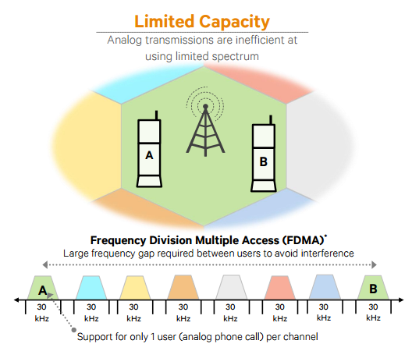](https://www.qualcomm.com/documents/evolution-mobile-technologies-1g-2g-3g-4g-lte)

Figure 1- FDMA based on AMPS 1G technology [5]

In the 1990’s, the **‘second generation’ 2G** mobile phone systems appeared, the first digital cellular network, bigger and better than 1G. The initial requirements for this network defined by CEPT/ETSI were more efficiency in radio frequency usage, low cost, low cost cipher in terms of security, QoS, Numbering ITU-T and signaling protocol in the network.

This generation introduced the GSM architecture in 1991 enabling more users per channel with TDMA technique but still requiring a large gap of spectrum between users to avoid interference. This architecture is divided in three parts: Mobile Station (MS), Base Station Subsystem (BSS) and Switching Subsystem (NSS). The first one consists of Mobile Equipment (ME) and a Subscriber Identity Module (SIM) containing the subscriber identity, a password (PIN), subscription information such as last received/dialed numbers, last visited location area and more used for authentication and other security procedures.

The BSS is composed by base station controller (BSC) and base transceiver station (BTS) placed in the center of a cell, geographic area covered by a [base station](http://www.telecomabc.com/b/basestation.html) and maps transceivers and antennas to the cell, whose size is defined based on BTS’s transmitting power. BSC manages radio resources of BTS’s and handles BTS and MS power control, handovers, channel allocation, etc. It also gathers the traffic towards the MSC [6].

At last the NSS it’s composed by MSC containing four databases (HLR, VLR, AuC and EiR) and the GMSC. The MSC manages the communication between the mobiles and the fixed network, handles authentication and registration from connections with subsystem databases. Home Location Register (HLR) maintains permanent information about the subscribers of a GSM network and tracks the location and state of the mobile terminal within the network, Visitor Location Register (VLR) maintains temporary information about the subscribers registered on a GSM network and keeps up-to-date information about the location of the user within the network, Authentication Center (AuC) is responsible for the authentication of the subscribers, maintains the encryption algorithms, the secret key for each subscriber and generates the session keys and finally Equipment Identity Register (EiR) provides security mechanisms for the mobile equipments and keeps lists of authorized or blocked mobile equipments

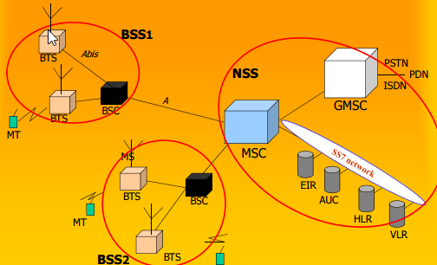

Figure 2 - GSM architecture

The second generation introduced SMS text, a new variant way to communicate and a alternative over voice calls nowadays preferred in many situations. In comparison with 1G digital signals consumed less battery power making mobile batteries last longer, these signals are also considered environment friendly. Voice clarity improved and was compressed into smaller “packages”and noise reduced in the line, furthermore the cost of cost/weight in digital components reduced a lot making possible have a pocket-sized device and still we assisted a improvement on security with encryption to the data and voice calls.

Mobile phone usage increased drastically and first’s prepaid mobile phones began to appear. However, although the network offer more capacity, the data was mostly just text messages and the delivery was rigid whether or not the user was actively talking. These constraints and 2G low air interface data rates were improved by High Speed Circuit Switched Data (HSCSD) and General Packet Radio Services (GPRS).

HSCSD uses multiple time slots per user (max 6) and increased data throughput. However, since its circuit switched it allocates the time slots even when nothing is being transmitted increasing blocking probability of the system.

On another front GPRS was the new technology that made possible to make phone calls and transmit data at the same time. It’s architecture provides both circuit switched and packet switched data for voice and data traffic respectively, although as the name indicates it’s more a packet-oriented transport service. This period is seen as an extra period of mobile networking called **2.5G**, new network applications appeared as well new services such as Wireless Application Protocol (WAP) access, Multimedia Messaging Service (MMS) or e-mails. With bit rates transmission improvements from 56 Kbit/s up to 115 Kbit/s, new user-oriented billing mechanisms (by traffic e.g.), it really was an important step towards 3G and the first evolution of GSM networks [4].

In comparison with GSM’s architecture in GPRS we have a BSS evolution with upgrades on BTS’s, BSC’s, network planning and new element called Packet Controller Unit (PCU). In NSS the core network was modified adding new packet nodes dedicated to GPRS (SGSN, GGSN) and Internet equipment like DNS servers and firewalls. We also assist an evolution of HLR, VLR, SS7 that we already known from GSM.

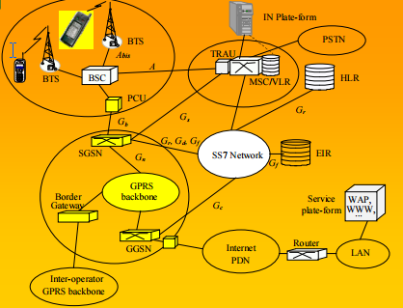

Figure 3 - GPRS architecture

With no new technology required was found a way to double the transfer speed of 2.5G, but still was not fast enough to reach the 3G standards defined for the future. The idea was change the modulation scheme to 8-PSK and with link adaptations only software upgrades was required to increase the data rates. This technology was called EDGE or EGPRS and as explained it’s an extended only version of GSM.

Operators and providers revenues were coming mainly from voice (>70%) and the mindset was migrating towards more applications, services and new systems. Technological progress and voice/data combination contributed as well to motivate a new system. Taking that in consideration European Telecommunications Standards Institute (ETSI) started the work, carried out later by Third Generation Partnership Project (3GPP) organization, for the next generation mobile networks in a system called Universal Mobile Telecommunication System (UMTS) [10].

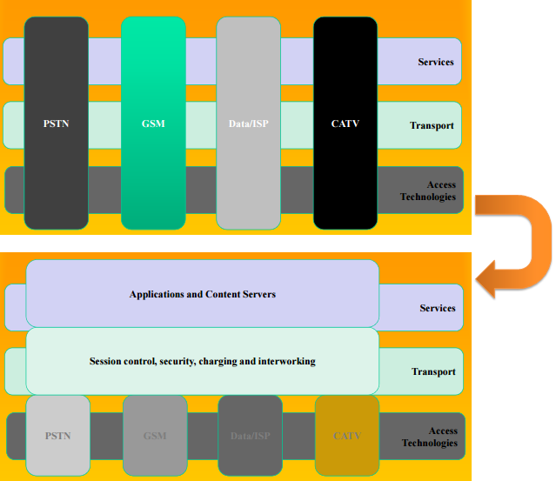 Combining aspects of 2G the 3GPP model idea was pass from a vertical model to an all uniformed service and transport layers to create a single set of services that apply

Figure 4 - Legacy Telecom Model and 3GPP Telecom Model respectively

network wide, generic application servers, a common session control, a consistent user experience and improving operational efficiency to any device anywhere and in any access technology.

The core network of UMTS has base stations called Node B and Radio Network Controllers (RNC). These components together form the Radio Network Subsystem (RNS) similarly to BSS that we saw before.

In release 5 IMS was introduced, with the same core network it was the architectural foundation for next generation networks. It defined a common framework for delivering IP-based multimedia while maintaining QoS, billing and service integration. Release 6 extended to wideband fixed networks (xDSL, WLAN, cable, …) and supported services convergence on fixed and mobile networks (circuit-switched voice traffic in IP). For network providers this bring a lot of advantages because a universal network reduces operational expenditures and service providers reaches a new and broader marker and functions of authentication, charging and billing could now be outsourced [21].

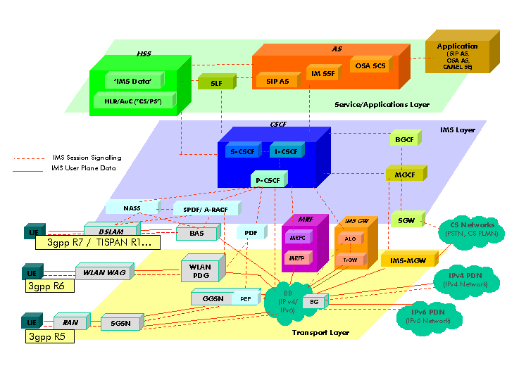

Figure 5 - 3GPP IMS architectural overview

Before the fourth generation some sources consider an extra period, **3.5G** or **3G**+ where mobile telephony protocols like HSDPA and HSUPA provided a smooth evolution on data rates of 3G networks. Complimentary to each other, HSDPA is a packet-based data service in WCDMA downlink, already HSUPA is a UMTS / WCDMA uplink evolution technology that will enhance P2P data apps, e-mail, gaming, etc due to this boost in the link speed.

[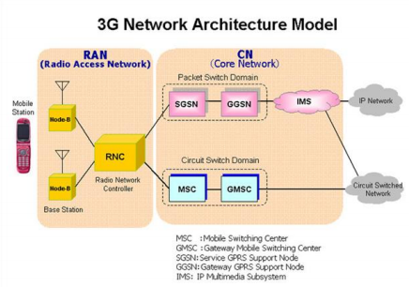](https://www.linkedin.com/pulse/evolution-mobile-communication-from-1g-4g-5g-6g-7g-pmp-cfps)

Figure 6 - 3G architecture model [10]

The successor of 3G UMTS was developed by 3GPP and is known as LTE. This **4G** network must deliver speeds of 100Mbps while moving, 1Gbps while stationary and smooth handover going from 4G to Wi-Fi and back with data or call interruptions. It has VoIP incorporated and utilizes packet switching over internet, LAN or WAN networks, the improvements on speed, reliability, capability, security and global mobility are also important upgrades from 3G technology.

The 1st successful field attempt for 4th generation networks was performed in Tokyo, Japan on June 23rd, 2005. Also known for the high quality audio and video streaming, low cost in roaming network and provide services anytime this network merges various numerous radio access interfaces into a single network that can be accessed by every subscriber.

Quality of service was one of many targets, in video chat, mobile TV, DVB and many other services that make use of bandwidth. Other targets include improved latency, spectrum efficiency, RF coverage, reduce CAPEX and OPEX and have compatibility with earlier releases, systems (including handover) and system wise providing a steady experience to user [23].

LTE radio access network is called EUTRAN (Evolved Universal Terrestrial Radio Access Network), it also has an air interface called EUTRA (Evolved Universal Terrestrial Radio Access). The entire core network is known as EPC, it provides IP connectivity between user equipment and an external packet data network using EUTRAN, in addition it hosts the ‘control plane’ elements that provide administrative features, session management and security. LTE base stations in EUTRAN are called eNB (EUTRAN Node B), these elements perform and take care of access control functions. Still about the radio interface it uses OFDMA, a multiple access technology on the downlink that transmits traffic across hundreds of parallel radio connections known as ‘subcarriers’. An adapted version of this is SC-FDMA used on the uplink [7].

Mobile 4G LTE complements 3G providing more data capacity for richer content, more connections and along speed and services, billing systems are also an key aspects for the success of the 4G systems

[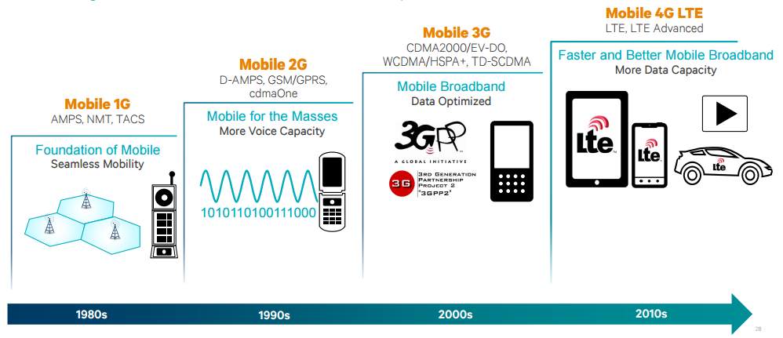](https://www.qualcomm.com/documents/evolution-mobile-technologies-1g-2g-3g-4g-lte)

Figure 7 - Mobile technology evolution [5]

In 2020 it is expected that **5G** mobile technology will be fully operational in a connected society. Different research groups standards like Mobile and Wireless Communications Enablers for the Twenty–twenty Information Society (METIS), 5th Generation Non-Orthogonal Waveforms for Asynchronous Signaling (5GNOW), 5G Infrastructure Public Private Partnership (5GPPP) and many others organizations from America, China, Japan, Korea, Russia and many others around the world are actively working on different aspects and areas of 5G. Appendix A has a more detailed view about those projects and activities that are being developed all over the world.

On April 30 2015 METIS published a final report about their evaluations on a high level architecture that showed the filter bank multi-carrier (FBMC) to be a successful enabler for designing flexible air interfaces [8]. They are moving for METIS-II project now focusing in 5G RAN and RAN design as their results also showed latencies under 1ms in RAN architectures. Viable waveforms, ultra-high reliability and low latencies, MIMO transmissions, energy and channel efficiency in both wireless and networking are being researched as well [9].

In terms of modulation techniques four waveforms are currently being considered over the previous OFDM in LTE-Advanced (4G). Those are GFDM [11], UFMC [12], FBMC [13], and BFDM [14] and aim to improve the spectral efficiency and air-interface that is no longer dependent on stringent orthogonality and synchronization requirements.

For socio-technical requirements 5G has limits on energy dissipation, more context-related information (e.g. augmented reality), broadband Internet connectivity widely available, increased amount of remote virtual collaboration, more efficient and safer transportation means, personal data stored in the cloud and an improvement on IoT (e.g. smart homes and cities) being more available to society in general.

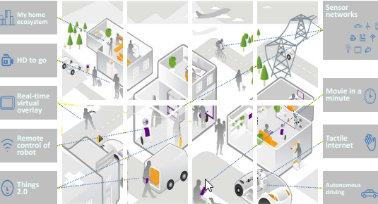

Figure 8 - 2020+ experience

There are currently limitations in 4G networks already like latency, spectral efficiency, the support for bursty data traffic and this aspects will be crucial for the future networks. Several mobile applications require sending messages to servers with high data transfer rate for a very short time and consume a lot of battery life time in mobile equipments [16]. Co-channel interference due to separate channels (DL and UL), in a typical cellular network and base-station utilization efficiency are also points where improvements can be done [17].

With that said 5G networks and because the number of devices like smartphones, TV’s, cameras, robots, video surveillance systems, high-resolution TVs, laptops and wearable devices (watches and glasses) connected is expect to continue grow in the future will focus on scalability, high data rates, spectrum utilization, low latencies that will supposal increase the level of QoS and QoE with more satisfaction from users, which we will discuss in section 2.2 and last but certainly not least, ubiquitous connectivity because operating bands are not identical over the globe and UE have to support a variety of radios and RATs [15, 18].

In summary 5G networks will be more flexible with a lot of users requesting for different set of services simultaneously, having higher data rates, higher capacity, energy optimization, mobility, availability, reliability, connectivity, cost effectiveness, accuracy traffic, and less latency improving areas like IoT, gaming, personal clouds, and many areas on society with new applications for tourism, agriculture, e-government or e-health, however still facing many challenges such as security, privacy models not really clear and more devices connect consequently bring more and new vulnerabilities, those low energy impositions mentioned before will break uniform networking, structure management with self-healing to perform dynamic operations, interference handling, handoff in very high speed vehicles and furthermore “in network densification how much network density is good?”

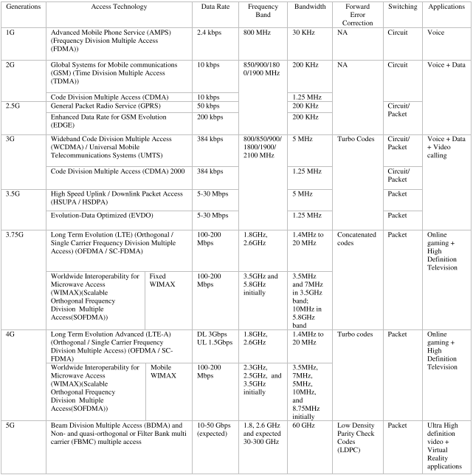

Table 1- Evolution of wireless technologies [25]

## Quality of Service

Quality of Service (QoS) for networks is a set of mechanisms, standards and protocols for ensuring high-quality performance and granting end-to-end consistent treatment to the data flow as they travel through the network. Taking this into account network can then be managed using the existing resources efficiently to ensure a QoS level and improve the final user global experience using the service.

Treating all the network traffic equally leads to no guarantees for reliability, delay and other performance parameters that we will mention after with a more detailed approach. For some services or applications the QoS is an important requirement and can even be critical if some traffic needs to have preferential treatment.

QoS provision in 4G networks is a challenge because the network “supports varying bit rates from multiple users and variety of applications, hostile channel characteristics, bandwidth allocation, fault-tolerance levels, and frequent handoff among heterogeneous wireless networks” [19].

QoS support can occur at the transport, application, network, user and switching levels and to evaluate QoS performance there are some metrics we can use, such as, latency (delay in data transmission from source to destination), jitter (delay variation), bandwidth (the rate at which traffic is carried by the network), throughput and reliability or packet loss rate. Resource reservation and service prioritization can help improve these parameters, furthermore we can apply QoS according to per flow (individual, unidirectional streams) or per aggregate (two or more flows having something in common) basis.

In section 2.1 we have already seen that improve QoS in 5G Networks is a must. Based on the projections the number of machine to machine (M2M) connections in the networks of mobile operators will surpass 20 billion [39], two times more than the present number and in 2022 mobile operators will have more than 26 billion machine to machine connections.

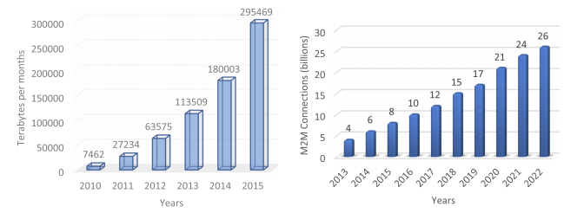 It is expected to significantly improve customers Quality of Service in the context of increasing growth of data volume in mobile networks and the growth of wireless devices with variety of services provided. Some general trends related to 5G can be explained in terms of machine to machine traffic and number of machine to machine connections in mobile [36]. With these huge numbers at sight the network source data rate, delay bound, cell spectral efficiency and latency in 5G needs to be improved and that is supposed to be attained using non-orthogonal access methods in radio access networks [38].

Figure - Machine to machine traffic and connections number respectively [36]

The 5G networks are supposed to satisfy the highest level of QoS, a big issue about this topic is the tactile Internet requires the best QoS, especially, latency of the order of 1 millisecond for senses such as touching, seeing, and hearing objects far away, as precise as human perception. However, the current proposed architectures do not support efficient tactile Internet services. In future, it would be a promising area as to encode senses, exchange data satisfying the zero latency, and enable the user to receive the sensation [37]. Lastly for cloud is proposed the deployment of a quality management element (QME) in the cloud for monitoring inter-UEs and inter-layer (the control and the data layers in C-RANs) QoS.

## Quality of Experience

User’s satisfaction is the ultimate target for a service provider achieves success. QoE describes the user’s perception about a service and how well the service fulfills the user’s expectations. Defined by [49] is “a user-centric metric that captures the overall acceptability of the service and includes the end-to-end factors”.

Contrary to previously mentioned QoS this is a more “subjective” concept as it doesn’t have only specific metrics like latency or throughput and is dimensioned or evaluated many times with terms like “Good”, ”Fair”, “Poor”. Nevertheless this perception is composed by subjective factors and overall experience, QoS differ from QoE because doesn’t really capture the actual experience of the user and that can dictate the use or not of an entire system or service [50].

With all of this in consideration some sources consider QoE as an extension of QoS as it try to capture a service performance with metrics that could be directly communicated by user, for example, the playback start time of a task, or in video streaming the number of interruptions on watching a video, the duration of those interruptions and how that affects the user or the user engagement with that specific video can contribute to a good or not quality of experience.

One way to try evaluating QoE in general with those more subjective factors is the use of Mean Opinion Score (MOS) classification. Users use the system/service and then rate it on a five-point discrete scale: 1-bad, 2-poor, 3-fair, 4-good, and 5-excellent. It is not easy to automate this process since many times the parameters to have in consideration are too many from user’s age, genre to device screen size, device capabilities or internet connection [51]. Also there are recent studies [52] that indicate that user’s psychological state, being this on pressured situation rather than relaxed situations can affect QoE perception of a service.

## Study of Market

Now that we know the motivations and objectives of the present dissertation it’s time to present what similar solutions are available on the market and what they do. ArQoS Pocket solution and its features will be presented and described in detail in the next chapter, but very briefly it is an Android app that measures and tests Wi-Fi and mobile network in the various technologies and communicate with a backend that gather and process all the information given, for present an overall or more detailed state of the network to operator.

There are a couple of applications in the market testing the network and retrieving radio information like the cell signal strength, cell id, operator’s name, technology, if the roaming is active or not and many others that can vary with the mobile network technology that is being used in that moment. For the Wi-Fi network parameters like BSSID and SSID (network name), ip and mac address, etc. Information about the device and its specifications such as location, battery level or free memory available in the device will be relevant for some task that we will refer in chapter number 3 and that’s possible to retrieve too from Android intern classes. Many of this apps have a lite version free to user test in market but have as well a more detailed and paid version exploring other features and deeper.

In the QoE optic was founded some apps where user could input of bad coverage zones, drop calls, bad quality audio or no data to the operator in order to give feedback helping this understand faster where are the points that needs some improvement. Were also founded scenarios where the solution was focused on drive tests and vehicle installation passively testing and taking snapshots of the network through the city. Scheduling tests to a specific date and hour were also possible and an interesting feature that was implemented as well in our solution.

Tests made could vary in simple PING’s, HTTP Download/Upload, send a SMS/MMS or access an e-mail server, but some expensive solutions encountered also gave access to voice tests using PESQ and POLQA, OTT applications like Skype, video streaming quality and other applications in vogue like facebook, YouTube and dropbox in the various technologies (EDGE, GSM, HSPA+, LTE, …)

## VoIP

Before write about VoIP, is important to give a briefly overview of the Internet Protocol procedures. When a user establishes an Internet connection, most of the times the ISP (Internet Service Provider) assigns a public IP address to the computer, which uniquely identifies the network. IP is a protocol that allows the sending of the information, in the form of small packets, from one personal computer (PC) to another, through the Internet.

Voice over IP allows the user to establish telephone calls over a data network such as the Internet, converting an analog voice signal into a set of digital signals in the form of Packets with IP addressing.

The quality of service perceived by the user depends not only, but primarily on three aspects: Network topology, interconnection congestion and codecs used. Network topology because the delay in packets delivery can affect the quality and these delays depend of the number of nodes between the two points in communication. Interconnection congestion because other calls in curse on the network can affect the quality of the service and codecs used since voice signal compression can deteriorate or delay the communication, on the other hand, some codecs that usually require more computational processing have a corrective effect on transmission problems, minimizing the impact of packet loss.

### VoLTE

LTE network architecture was already explained on section 2.1, Voice over Long-Term Evolution (VoLTE) is based on the IP Multimedia Subsystem (IMS) referred in the same section, with its owns profiles for media and control planes well defined by GSMA. Using the IMS central network means that we are using LTE architecture with no dependency on legacy [circuit-switched](https://en.wikipedia.org/wiki/Circuit-switched) network to carry calls and being an IP-based data connection it makes VoLTE has three times more voice and data capacity than 3G UMTS.

Being a new technology VoLTE has a couple of challenges yet due to multiplicity of protocols, technologies and implementation scenarios. In the situation of an international roaming the call SIP signaling path and voice path are not essentially same because signaling could go through one or more Internet Exchanges (IPX). Also “the standards for voice facilities over LTE on 3GPP IMS are still growing” and carriers need to re-engineer their voice call network. Lastly we have the user quality of experience challenge in the sense that VoLTE needs to deal with the fact that a user can leave the LTE area coverage during a call and then make the call go via legacy network with CSFB technique [42].

It is needed to point out that VoLTE implementations are not yet interoperable, the technology is new and still needs development to reach an ideal level of quality. However if we manage to overcome the challenges previously mentioned we will have calls with fast connections, HD Voice since the audio compression by VoLTE can reach the 13kbps and the 700MHz band contributes to more clean audio calls. Other benefits that can come are the possibility of operators offer to final user an extra service package containing, for example, video calls, file transfers, attachments or automatic translations, in addition if we compare VoLTE with OTT apps like Skype the battery consumption level of device will be lower on VoLTE service [40].

To finish this topic, there is an mobile network operator in India called Reliance Jio Infocomm Limited that lacks legacy network support of 2G/3G services and provides only wireless 4G LTE service network that offer VoLTE services to all those who have a Android 4.0 or higher compatible VoLTE device, a list can be found on Appendix B, with their own SIM card, Jio SIM Card [41].

### VoWiFi

To increase network capacity and extend their voice services, carriers are likely to use VoWiFi to extend coverage particularly indoors. VoWiFi is a solution that mobile services providers can deliver “the same set of mobile voice and messaging services they currently offer over their macro cellular network, over any Wi-Fi network” [43].

Such as VoLTE, this technology is defined by mobile industry standards organizations (3GPP and GSMA) and will allow a transparent transaction between cellular network to any home, office or public Wi-Fi network. VoWiFi can really shine in helping with indoor coverage as it is well known that the majority of mobile calls is made indoors and provide good coverage in some scenarios is more complex and expensive than we think, especially in lower floors or in internal rooms.

Apart from extend reach, VoWifi can potential save millions of dollars to some operators as calls placed on a smartphone would be carried over the consumer’s broadband network, enables traffic to be off-loaded to another network and freeing up some cellular capacity [44]. The control of subscribers is still completely retained by operator when a VoWiFi-enabled subscriber connects to Wi-Fi, they attempt to connect to operator’s core network and register to receive the service, once authorized, traffic is routed over the Wi-Fi/Internet connection instead of the macro cellular network continuing the operator to handle all billing, charging and routing.

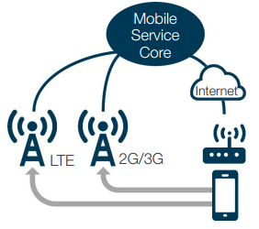

Figure - Calls over Wi-Fi and cellular network

VoWiFi service quality is expected to be as good as, voice quality over the cellular network, since the connections are over the internet and typically the Wi-Fi networks at home and office have good throughput, congestion and coverage overall, however in public Wi-Fi networks those are variable factors that can affect the VoWiFi quality. Another issue to be taken into account is that carriers should also bear the cost implications for incorporating emergency service support to ensure that these calls go through [43].

Still, there is a cost and need to deploy an IP multimedia subsystem, but if operators already have VoLTE this already have been paid for as the same IMS core network supports both of these services and there is no doubt that VoWiFi will make OTT apps like Skype, Viber or WhatsUp be less relevant for user as long as they have Wi-Fi indoor coverage.

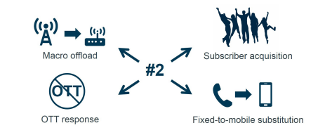

Figure - VoWi deployment reasons

## Audio Quality

The phone call quality is an essential feature to satisfy service subscribers, but are they satisfied with the quality of this voice service? Regardless of the more sophisticated and powerful networks and smartphones “none of the 100 plus cellphones in Consumer Reports’ got an excellent or even a very good rating, for voice quality [45].”

This can be explained by many reasons: smartphone size with cameras, radios, microprocessors and other hardware that allow those tiny devices do all the great stuff they do. Perhaps sometimes the “speaker is wedged between the bezel and the front-facing camera” covered in plastic and microphone on the back of the phone. Additionally the reasons why voice calls aren’t perfect are not only due to devices, the closest base station can be loaded at that time of the day or the distance that the packets have to travel till they reach its destination because signal has to jump from cell to cell and every building, mountain or even the weather it’s an obstacle making possible to have more than one path to reach the destination. Deciphering this multipath signals that reach to smartphones at different times is not easy having the signal sometimes to be retransmitted happening all of this in fractions of a second. Moreover, although a call can be done almost everywhere, if we have coverage, some places are often very noisy or with a lot of background sounds like traffic or nature sounds and neither noise-canceling technology that some phones have can make miracles [47, 48].

Due to all those experiences that we already had with voice calls, alternatives like texting, e-mail and instant messaging are constantly growing at the moment, but we have promises of improvements with HD voice transmitting at a range of frequencies from 50Hz to 7kHz that are more close to human voice frequencies (75Hz-14kHz) than the oldest telephone network that had this ranges between 300 and 3,400 Hz, perhaps we have to wait for the network backbone to be upgraded because the circuit-switched backbone still uses standard voice technology.

Thus, even though most of the new phones already support HD Voice, there is no notice yet on voice quality changes because carriers still have to activate AMR-WB codec that extends the frequency range of audio signals and deliver voice traffic over IP compressing and digitalizing voice signals and send it as data packets. VoLTE technology is the bet for fix this problem and boosts the cellular quality voice as it already supports AMR-WB, so it’s not very difficult for carriers like AT&T and Verizon to enable HD Voice once calls have moved over to its LTE network. Backbone networks, local broadband links, IMS infrastructure and other issues like ensure priority for different traffic over the LTE network are being studied and developed and it will not take much time to “let VoLTE packets flow seamlessly between mobile handsets and other IP phones” [46, 48].

## Android

Android is a Linux-based Operating System for mobile devices, it was developed by Open Handset Alliance but is owned by Google nowadays. This system is designed for touchscreen devices so the primarily market target are smartphones, tablets, Android TV and some gadgets that run android, for example, watches (Android Wear).

### Android History

Everything started on Android Inc. a company founded in October 2003 to develop “Smarter mobile devices that are more aware of its owner's locations and preferences”. The first intentions were to develop a system for digital cameras, but when they realized that the market was not big enough the attention and effort turned to produce a mobile operating system to rival Symbian and Windows Mobile at the time.

Google bought Android Inc. in 17th August 2005 developing a mobile operating system and making partnerships with mobile operators, software and hardware companies reaffirming that it would be open to mutual cooperation. Said that, the first commercially available smartphone running Android was the HTC Dream, released at October 22, 2008.

To show their latest updates and new features on Android versions Google usually launches a new Nexus device as pilot, for example, the Nexus 5, made by LG or Nexus 7, made by Asus containing these upgrades and errors/bugs fixes. At each major update the system’s codename is changed, in alphabetical order, being always candy names.

**Android 1.0 Alpha** was the first version of Android and it incorporated a Android Market that allowed application downloads and updates, a web browser, Wi-fi and Bluetooth support, a bunch of Google apps like Maps with Street View, Contacts, Calendar, Google Sync, Google Search, Google Talk and many more. It also had a YouTube video player, access to web email servers supporting POP3, IMAP4, and SMTP, a Voice Dialer, instant messaging, MMS and the option of user customize its own wallpaper.

To resolve a couple of bugs found when the OS first launched on February 9, 2009, the **Android 1.1 Beta** update was released. It added some new features too, such as the possibility of save attachments in messages, a longer in-call screen timeout and details and reviews for businesses on Maps.

The first release to officially use a codename based on a candy name was **Android 1.5 Cupcake,** it bring the copy and paste feature in web browsers, support for widgets and personalised homepages, auto-rotation option, animated screen transitions, user picture shown for Favourites in Contacts, third-party virtual keyboards with text prediction and user dictionary and the ability to upload videos and photos to YouTube and Picasa.

On September 15, 2009, **Android 1.6 Donut** brought a more powerful and redesigned Android market, the capacity of Android to run on more devices with different screen resolutions and aspect ratios and upgrades in Quick Search Box showing results from the web and phone’s local content. [27]

The **Android 2.0 Eclair** was lauched on Motorola Droid that had huge hardware improvements compared to HTC Dream/G1, integrated Facebook, speech-to-text, Google Maps directions and multiple account support were some of the more important features added with this update. Two versions were release after 2.0.1 and 2.1 (API 6 and 7, respectively) correcting minor bug fixes and in 2010 **Android 2.2 Froyo** was launched in Nexus One with five times more performance in CPU due to Dalvik JIT compilerand 2-3 times more performance in Android browser due to the V8 JavaScript engne. Froyo also let you turn your phone into a portable Wi-Fi hotspot and took voice capabilities to another level allowing perform key actions like searching, getting directions, setting alarms, and more with just the sound of user’s voice [30].

After that **Android 2.3 Gingerbread**, using Nexus S as flagship phone brought improvements on battery, NFC support and Gaming API’s catapulting Android gaming to a more intense experience with richer 3D games. The following incarnation of Android was created thinking on tablets but didn’t quite hit the levels of popularity expected. With improvements on multitasking and with larger layout patterns, **Android 3.0 Honeycomb** enhanced the experience of watching videos, exploring maps and reading books.

Upgrading and refining lots of elements of honeycomb **Android 4.0 Ice Cream Sandwich** appeared, followed by **Android 4.1, 4.2 and 4.3 Jelly Bean** with expandable notifications and a big step up on user experience, elimination most of the lag and making the operating system more quicker and responsive to users.

In 2013 was announced the **Android 4.4 KitKat** although initially under the codename of "Key Lime Pie" the name was changed because very few people actually know the taste of a [key lime pie](https://en.wikipedia.org/wiki/Key_lime_pie). Some of the more important new features of this Android version were support to wireless printing, NFC card emulation, Android Runtime as a experimental application, Bluetooth Message Access Profile (MAP) and GPS support. [28] A exclusive version of KitKat was release in 2014 for Android Wear devices and in the same year **Android 5.0 Lolipop** was unveiled with a brand new fresh design and lots of shortcuts to applications and notification settings. In Android 5.0 was also introduced the smart lock feature and was added support for 15 new languages. The official support for multiple SIM cards and the high-definition voice calls that we will explain

after were introduced already in the 5.1 version.

Unveiled as "Android M" during [Google I/O](https://en.wikipedia.org/wiki/Google_I/O) on May 28, 2015, **Android 6.0 Marshmallow** is a well known version for application developers because we have to ask for permissions in app at runtime, wich did not happen in previous versions. This version also introduced Doze mode which reduces CPU speed while the screen is off in order to save battery life, native fingerprint reader and USB Type-C support, 4K display mode for apps among others.

Finally the most recent version of Android, launched at 2016 during Google I/O, **Android 7.0 Nougat**, that now it’s in version 7.1.2 (April 4, 2017) has the incredible capacity in divide the screen in multiple which is awesome for the multitasking user experience, native encryption, new emojis, change interface and font size, virtual reality support, the ability of send messages thought the notification bar and more to explore [29].

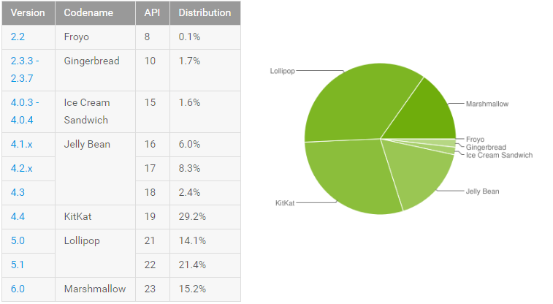

Figure 12 - Number of devices per Android version in 1 August 2016 [31]

### Root/Jailbreak

So Android phones use Linux permissions and file-system as we mention before, therefore we have a different privilege level for processes and users. These determine what the process is allowed or prohibited from doing. All new apps that we install have a type of user ID, and certain permissions to do certain things.

Root is nothing more than a user, but he has permissions “to do anything to any file any place in the system” [32], consequently this brings an incredible power to user since he can overcoming limitations that carriers and hardware manufacturers put on the device like uninstall pre-installed applications, speed-up the phone with over clocking or modify any file as he want, perhaps “with great power comes great responsibility” because changes you do or apps that have root access do in the system file could lead to security risks if you aren’t sure of what you doing [34].

The process of allowing Android devices to have privileged control (root access) is called rooting and it gives similar access to administrative permissions to *superuser* on Linux. Is this process legal? Yes, if you are the owner of the device, also if you use it to install spyware on other people’s phones that is a crime in certain countries around the world. Other than this many vendors such as HTC, Sony, Asus or Google provide the ability to unlock devices or even replace whole operating system, but keep in mind that on doing this you are “changing everything about the inherent security from Google and the people who built it” [32] and you will almost certainly void the warranty of your phone. Continuing with the topic if you need your warranty service for some hardware issue after is it possible to unroot your phone? Yes, you can often find instructions for unroot your phone, usually it involves flash a SBF(system binary file) or a RUU, however some phones have a digital “switch” that flips when you unlock your device that is very difficult to revert, so remember to do some research before unlocking if you need your warranty [33].

The steps for rooting an Android device are in general unlocking or bypassing any bootloader protection to allow the system partition to be written and installing the relevant binaries to acquire root. Both of these steps vary from phone to phone, install a custom recovery, temporarily boot from an image over USB or flash a new bootloader are common procedures that can help advance with the process. Other devices can be unlocked by accessing *fastboot* with a push-button combination, also many manufacturers now offer an official route to unlocking the bootloader.

If you root your phone without flashing a custom ROM, you will likely still get OTA updates from your carrier, perhaps they will likely break your root, fortunately there are some free apps that can help you keep your root access. Otherwise if you flash a custom ROM, you will not get OTA updates from your carrier [33].

### System apps vs. Non-System app

Searching for an application on Google Play Store and click install or loading an APK to the device always install the app as data or user apps. However there are some scenarios where we need to install an application as system app to be able to do certain actions such as programmatically change or add an APN to the device among other features that Android only permits to system app. This is due to certain permissions are protected under the "*signatureOrSystem*” protection level. Such permissions are not available to every application because they will grant risky privileges such as control over other applications, background installation and un-installation, among others. Such permissions can be utilized for malicious purposes, therefore Android will only grant them for system applications or ordinary applications signed by platform signatures [36].

A common mistake believed by many is that a system application is an application which is signed by the OS’s platform signatures. A System application is merely an application which is placed under /system/app folder on an Android device. An application can only be installed in that folder if we have access to the OS's ROM (system.img). The application is placed under /app folder after the ROM has been extracted. A device which loads the custom ROM will have the new System application added. The benefit of a system application is that the application cannot be removed from the device (cannot be uninstalled by the user). This is only because /system/app is a read-only folder [35].

A non-system application is an ordinary application, which will be installed under /data/app folder, and which is read-write. We can check easily if an application is a system application or not using “*ApplicationInfo.FLAG_SYSTEM”*. If the constant returns true, then the application in question is a System application.

### Comparing Video Quality

Comparing quality of videos is not so simply because we cannot only compare video resolution, in fact, that could be really misleading because a 1080p movie rip at 700MB size might look worse than a 720p rip at 700MB, this is due to the fact that for the former the bitrate is too low and it affects the compression. We can apply the same principle for comparing bitrates at similar frame sizes because the encoders can deliver better quality at less or higher bitrate, for example, a 720p 700MB rip produced with XviD will look worse than a 700MB rip produced with x264, because the latter is much more efficient.

To evaluate video quality exist a variety of quality metrics, but we can divide them in two big groups, no-reference metrics and full-reference metrics. The first ones simply have a video and output a quality score. Most of the times we will not have access to the original video to make comparison, but if that’s the case we can use full-reference metrics to estimate the quality loss, obviously this takes longer time to compute.

In fact to try defining a MOS composed of individual quality factors we had to consider at least video length, the viewing audience, original frame size, “quality” before the encoding and the type of video (cartoons, movies, news, etc.), not to mention that some people watch a movie sometimes for its content and they probably don’t care about the quality so much, as long as the movie is funny or entertaining.

In Android case we have a video encoding recommendations that Android media framework supports for playback in the H.264 Baseline Profile and and VP8 media codec.

|  |  |  |  |
| --- | --- | --- | --- |
|  | SD (Low quality) | SD (High quality) | HD 720p (N/A on all devices) |
| Video resolution | 176 x 144 px | 480 x 360 px | 1280 x 720 px |
| Video frame rate | 12 fps | 30 fps | 30 fps |
| Video bitrate | 56 Kbps | 500 Kbps | 2 Mbps |
| Audio codec | AAC-LC | AAC-LC | AAC-LC |
| Audio channels | 1 (mono) | 2 (stereo) | 2 (stereo) |
| Audio bitrate | 24 Kbps | 128 Kbps | 192 Kbps |

Table 2 - Examples of supported video encoding parameters for the H.264 codec.

|  |  |  |  |  |
| --- | --- | --- | --- | --- |
|  | SD (Low quality) | SD (High quality) | HD 720p (N/A on all devices) | HD 1080p (N/A on all devices) |
| Video resolution | 320 x 180 px | 640 x 360 px | 1280 x 720 px | 1920 x 1080 px |
| Video frame rate | 30 fps | 30 fps | 30 fps | 30 fps |
| Video bitrate | 800 Kbps | 2 Mbps | 4 Mbps | 10 Mbps |

Table 3 - Examples of supported video encoding parameters for the VP8 codec.

It is also possible retrieve a variety of parameters from CamcorderProfile Android class, available since API level 8, such as vídeo codec format, bit rate, frames per second, áudio codec format, etc.

Chapter **3**

# ArQoS Pocket solution

This chapter presents a solution to complement the ArQoS system referred in the previous chapter. It is an android app solution that works as a mobile probe collecting multiple data and indicators of the network.

Supporting multiple technologies on mobile networks (GSM, GPRS, UMTS, HSDPA, HSUPA, HSPA+, etc) and Wi-Fi this solution allows continuous tests to check the connectivity and availability of the network, as well as help in troubleshooting and monitor the quality of service with more intrusive tests.

The key features of the ArQoS Pocket solution are:

* **Integration** with ArQoS management system;
* **Scheduling** personalizedtests;
* An alarm **failure** **notification;**
* Tests and anomalies are **saved** and can be seen in a **history tab** with all the information and data associated to the test/anomaly [20].

## Overview and Objectives

## Use cases

## Requirements

## ArQoS Pocket Solution Architecture

Chapter **4**

# Developed Work

## Tests

There was been developed several tests in the building of this applications not only to grant quality of service to the user but to help troubleshoot possible problems in the network too. We can divide the tests into two categories: intrusive tests and passive tests, the intrusive ones introduce packets in the network in order to evaluate what is happening in the moment. Passive tests are tests there are running since the app starts, don't need to introduce data in the network and are note noticed by the user. Both this tests can retrieve important information about the environment around.

ArQoS Pocket app test Voice and Data. In Voice, we can simulate answering a voice call, hang up or record the in-call audio to analyze its quality after. In the data part, web browsing, PING, speed test, portal logins and many more useful tests are done. These tests will be explained in detail in the next sections.

### Intrusive Tests

…

### Passive Tests

… ….

* **Scan Wi-Fi Networks:** We have a few networks around us almost every time, in big cities more than a few. Know which network as the best signal level in the user place, network's name or which network have or not a security password to allow connectivity is very important to the user. Android does this scan natively periodically but we perform this scan in the app because we can retrieve valuable parameters from here that android doesn't give us in his main interface.

In this test, it is obviously required that the device’s Wi-Fi is turned on, so it is turned on in the beginning of the test, if it is not already. After that is performed the scan and the parameters we retrieve from this test are: ssid, bssid, signal level, management key protocol, security capabilities, frequency, timestamp, distance, passpoint, channel bandwidth, center freq and some more.

* **Write LogCat to a file:** Android has several files where he dumps information and what is happening in the system in that moment. The location of this files are not standardized (i.e. some can be ROM-specific):
  + */data/anr*: Some trace files seem to get here (Dalvik writes stack traces here on ANR, i.e. "Application Not Responding" aka "Force-Close";)
  + */data/dontpanic* seems to be a standard location (AOSP), and contains some crash logs including traces.
  + */data/kernelpanics* is another location but not having any "kernel panic" on the android device yet means no content there yet too.
  + */data/panic/panic_daemon.config*may point to other locations configured like /sdcard/panic_data/ mentioned Droid 2 also has a /data/panicreports directory.
  + */data/tombstones* may hold several tombstone_nn files (with nn being a serial, increased with every new file). As tombstones are placed for the dead, it is done here for "processes died by accident" (i.e. crashed) -- and it is what is referred to as "core dumps" on Linux/Unix systems. However, not all apps create tombstones; this must be explicitly enabled by the developer.

Most of logging is done on *tmpfs* but with reboot these data is lost. Most developers usually use these logs to help troubleshoot problems or crashes in applications but there is a lot more information there divided into 5 levels – verbose, debug, error, info and warning. So there have been concerns about privacy because despite we can write messages to logfile to use as debug also SMS/MMS, contacts information, e-mails, etc can be written [22]. Bellow, we can see some examples of relevant private information that can be used by hackers like GPS information:

Snippet 1 - Logfile - information about user location [22]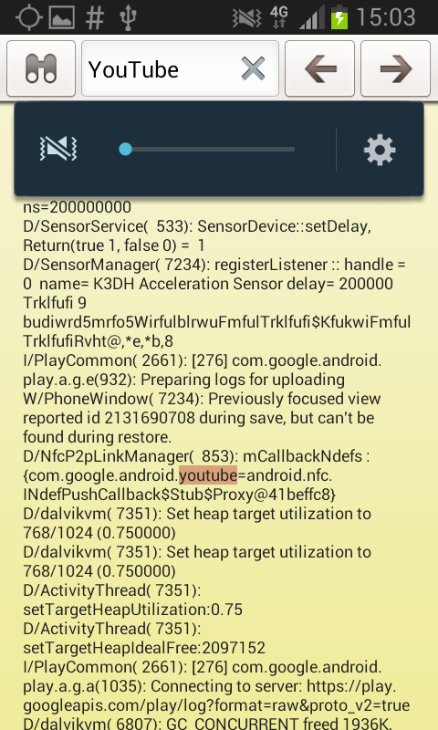

And many more examples can be given, accessing a Wi-Fi network can write the SSID of the network or the associated MAC address, after enabling Bluetooth was founded the Bluetooth address written in clear text or when a user opens a specific app, the logfile contains the package name of the selected app:



Snippet 2 - Logfile - open a specific application

Although all these examples founded in clear text, there is also information that can be sanitized. If we call toSafeString() method URI’s are sanitized before they are written into the “log file”. So URI’s started by “tel:”, “smsto:”, “mailto:”, etc are written as “xxxxxxx”



Snippet 3 - Logfile - sanitized information

Is this a problem nowadays? Yes, if you have a rooted phone. No if you have not. Since android version 4.1 Google don’t allow to read log entries from other applications anymore, so if you dump the “LogCat” to a file in an unrooted device ( > v. 4.1.x) you will only see log entries from your own app.

All of this information has been tested and for reading logs in rooted devices I had to grant permissions not only in the “Manifest.xml” but some in real time via shell commands, like this:



Figure 13 - Grant access to READ_LOGS via shell command

And after, call LogCat in a background process and send its content to a .txt file.



Figure 14 - Call logcat in runtime

* **Start call with a custom APN:** An APN is a gateway between a computer network, normally the public internet and the network used by the device technology (GSM, GPRS, 3G, 4G). In 3GPP data access networks APN is used to identify the packet data network that user wants to communicate with or to define the type of service (e.g MMS, WAP). It contains a mandatory *network identifier* that defines the external network to which the GGSN is connected and an optional *operator identifier* that defines the operator’s packet domain (e.g. Internet-v4.mnc111.mcc222.gprs, mmsc.tmn.pt).

In the development of this test was founded a list with 1370 APN’s and its configurations, in further investigations we confirmed that Google has a .xml file in android devices that keeps this information, normally under the /etc folder and the correct settings are defined by the SIM card inserted in the device.

Changing the preferred APN requires the application to be a system application. As explained in chapter 2 these applications are located under the *system/app* folder and have some permissions that user apps don’t have, allowing change and insert new APN’s on device’s configurations.

* **Send DTMF tones:** On the first telephones the dialing was done through a "disk" that generated a sequence of pulses, dual-tone multi-frequency signaling is a substitute for that on keypad phones. When a user presses a key is generated a high frequency and a low frequency based on the key pressed and the sum of the sinusoids of the two frequencies is then sent to the central that analyses the signal, knowing that the key was pressed.

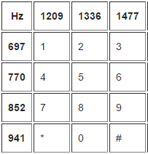

Tabel 2 - DTMF table

In the app are being sent a sequence of DTMF tones interacting with voicemail service automatically (e.g. "200,3,,4,,1”). Unfortunately in android is not possible to send this tones on the voice’s uplink during an active call as an app developer, but we can do it when initiate the call. There are a few contributions at the moment with new implementations of CallManager class waiting for Google developers to review and accept in “Android open source project” about the subject at the moment.

Chapter **5**

# Results and Discussion

Chapter **6**

# Conclusions and Future Work

# References

[1] **X. P. Kenechi Okeleke, M. Rogers**, The Mobile Economy 2017. 27 February 2017.

[2] “Improve Network Service Quality”*,* Optimize customer experience and network performance,http://www.alticelabs.com/content/products/BR_ArQoS_ALB_EN.pdf, Accessed at February 2017.

[3] **A. Jayanthiladevi, H. Premlatha, and G. Nawaz**, “Analysis study of Seamless Integration and Intelligent Solution in any situation by the Future Advanced Mobile Universal Systems 4G-(FAMOUS 4G)”, IEEE International Conference on Emerging Trends in VLSI, Embedded Systems, Nano Electronics and Telecommun.

[4] **Mora**, “2G, 3G, 4G or the evolution of mobile networks,” 2013. [Online]. Available: http://empireone.com.au/2g-3g-4g-mobile-network-evolution/. Accessed at March 2017.

[5] Qualcomm, (2014). "The Evolution of Mobile Technologies: 1G to 2G to 3G to 4G LTE" [Online], Available: https://www.qualcomm.com/documents/evolution-mobile-technologies-1g-2g-3g-4g-lte, Accessed at March 2017.

[6] GSM: Architecture, Tutorial Point, http://www.tutorialspoint.com/gsm/gsm_architecture.htm , Accessed at March 2017)

[7] 3GPP Technical Specification (2013) Numbering, Addressing and Identification, TS 23,003 v11.6.0 Section 19.6, www.3gpp.org, Accessed at March 2017.

[8] FP7 Integrating Project METIS (ICT 317669). [Online]. Available: https://www.metis2020.com/documents/deliverables/.

[9] Internet Resource, NEWCOM Deliverables 23.3: http://www.newcom-project.eu/images/Delivarables/D23.3- Secondreportontoolsandtheirintegrationontheexperimentalsetups.pdf

[10] **A. Dahiya**, "Evolution of Mobile Communication from 1(G) to 4G, 5G, 6G, 7G …" [Online], Available: https://www.linkedin.com/pulse/evolution-mobile-communication-from-1g-4g-5g-6g-7g-pmp-cfps, Accessed at March 2017.

[11] **G. Fettweis, M. Krondorf, S. Bittner**, GFDM—generalized frequency division multiplexing, in: 69th Vehicular Technology Conference, IEEE, 2009, pp. 1–4.

[12 **M. Mukherjee**, et al. Reduced out-of-band radiation-based filter optimization for UFMC systems in 5G, in: Wireless Communications and Mobile Computing Conference, IWCMC, 2015, pp. 1150–1155.

[13] **N. Van der Neut**, et al. PAPR reduction in FBMC systems using a smart gradient-project active constellation extension method, in: 21st International Conference on Telecommunications, ICT, 2014, pp. 134–139.

[14] **G. Wunder, S.A. Gorgani, S.S. Ahmed**, Waveform optimization using trapezoidal pulses for 5G random access with short message support, in: IEEE 16th International Workshop on Signal Proc.: Advances in Wireless Comm., 2015, pp. 76–80.

[15] Ericsson Mobility Report: On the Pulse of the Networked Society, Ericsson, 2016. Available at: https://www.ericsson.com/assets/local/mobility-report/documents/2016/ericsson-mobility-report-november-2016.pdf

[16] **F. Boccardi, R. W. Heath, A. E. Lozano, T. L. Marzetta, and P. Popovski**. Five disruptive technology directions for 5G. IEEE Communications Magazine, 52(2):74–80, 2014.

[17] **H. Elshaer, F. Boccardi, M. Dohler, and R. Irmer**. Downlink and uplink decoupling: A disruptive architectural design for 5G networks. In IEEE GLOBECOM, pages 1798–1803, 2014.

[18] Wireless World Research Forum, 2011. Available at: http://www.wwrf.ch/files/wwrf/content/files/ publications/outlook/Outlook7.pdf.

[19] **M. Mustaqim, K. Khan, M. Usman**, ”LTE advanced: Requirements and technical challenges for 4G cellular network”, Journal of Emerging Trends in *Computing* and Information Sciences, vol.3, Issue.5, pp. 665-671, May 2012.

[20] "Support system operations"*,* http://www.alticelabs.com/pt/sistemas_suporte_operacoes.html#garantia_servico, Official AlticeLabs website, Accessed at February 2017.

[21] **H. Wang, S. Chen, H. Xu, M. Ai, and Y. Shi**, A Software Defined Decentralized Mobile Network Architecture toward 5G, IEEE Network March/April 2015.

[22] **S. Rasthofer**, “The Android Logging Service – A Dangerous Feature for User Privacy?,” May 2013.

[23] **M. Rumney** (Agile Technologies), LTE and the Evolution to 4G Wireless, Design and Measurement Challanges: Wiley Publication, March 2013.

[24] *A One-Time Overview of Global 5G Initiatives as of the First Quarter of 2014*, Jun. 2014.

[25] **A. Gupta, R. Kumar Jha,** A Survey of 5G Network: Architecture and Emerging Technologies, IEEE August 7, 2015.

[26] **C. Welch**, “Before it took over smartphones, Android was originally destined for cameras" http://www.theverge.com/2013/4/16/4230468/android-originally-designed-for-cameras-before-smartphones” p. 1, 2013.

[27] **M. Meyer**, "A história do Android", Oficina da net, 2017. Available at: https://www.oficinadanet.com.br/post/13939-a-historia-do-android

[28] **Vítor M**, "A história do Sistema Operativo Android (Infográfico)", pplware, 2015. Available at: https://pplware.sapo.pt/smartphones-tablets/android/a-historia-do-sistema-operativo-android-infografico/

[29] "The Android History", https://www.android.com/versions/nougat-7-0/, Official Android website, Accessed at April 2017.

[30] **M. Mercato,** "A doce história do Android", AndroidPIT, 2015. Available at: http://www.androidpit.com.br/historia-do-android.

[31] Platform Versions, https://developer.android.com/about/dashboards/index.html Official Android website, Accessed at April 2017.

[32] **J. Hildenbrand**, “Everything you need to know about rooting your Android”, androidcentral, 2016. [Online]. Available: http://www.androidcentral.com/root

[33] **W. Gordon**, “Everything You Need to Know About Rooting Your Android Phone,” *lifehacker*, 2013. [Online]. Available: http://lifehacker.com/5789397/the-always-up-to-date-guide-to-rooting-any-android-phone.

[34]  **G. Sims**, “What is root,” *androidauthority*, 2016. [Online]. Available: http://www.androidauthority.com/what-is-root-680584/.

[35]  **Sergio**, “Explaining the behavior of an Android application: System apps vs Non-System apps,” *ricston*, 2013. [Online]. Available: https://www.ricston.com/blog/explaining-behavior-android-application-system-apps-nonsystem-apps/.

[36]  **H. Q. Raja**, “How To Install Any App As A System App On Android,” *addictivetips*, 2012. [Online]. Available: http://www.addictivetips.com/mobile/how-to-install-any-app-as-system-app-on-android/.

[36] **V. Tikhvinskiy and G. Bochechka**, ‘‘Perspectives and quality of service requirements in 5G networks,’’ J. Telecommun. Inf. Technol., no. 1, pp. 23–26, 2015.

[37] **Y. Park**, 5G Vision and Requirements, 5G Forum, Korea, Feb. 2014.

[38] 5GNOW, (5th Generation Non-Orthogonal Waveforms for Asynchronous Signaling) is a European collaborative Research Project Supported by the European Commission Within FP7 ICT Call 8, 2015.

[39] **M. Hatton**, The Global M2M Market in 2013. London, U.K.: Machina Research White Paper, Jan. 2013

[40] **E. Elkin**, ["The Secret Value of VoLTE"](http://blog.tmcnet.com/next-generation-communications/2014/04/the-secret-value-of-volte.html), TMCnet, April 2014.

[41] “4G VoLTE devices list in India – Updated (09-04-2017),” *newsmarkets*, 2017. [Online]. Available: http://newsmarkets.in/4g-volte-devices-in-india-updated/.

[42] **Mike Wright**, "The Next Generation of Voice Calling Starts Today – Telstra VoLTE", September 2015.

[43] “Top 10 Questions About Kombucha & Sugar,” *Kombuchakamp.Com*, 2015.

[44] "ACG Research: With VoWiFi, it's all about the economics",  *Fierce WirelessTech,* Oct. 2015.

[45] “Consumer reports: cell phone voice quality put to the test", *abc7ny*, 2015. [Online]. Available: http://abc7ny.com/technology/consumer-reports-cell-phone-voice-quality-put-to-the-test/788284/.

[46] **E. Malykhina**, “Why Is Cell Phone Call Quality So Terrible?,” 2015. [Online]. Available: https://www.scientificamerican.com/article/why-is-cell-phone-call-quality-so-terrible.

[47] **M. Gikas**, “3 reasons voice quality on smart phones still sucks,” 2014. [Online]. Available: http://www.consumerreports.org/cro/news/2014/05/3-reasons-voice-quality-on-smart-phones-still-sucks/index.htm.

[48]  **J. Hecht**, “Why Mobile Voice Quality Still Stinks—and How to Fix It,” 2014. [Online]. Available: http://spectrum.ieee.org/telecom/wireless/why-mobile-voice-quality-still-stinksand-how-to-fix-it

[49] ITU-T Recommendation P.10/G.100-Amendment 2. Vocabulary for performance and quality of service. Recommendations of the ITU,Telecommunications Sector, 12 2012.

[50] **P. L. Callet, S. Möller, and A. Perkis,** “Qualinet white paper on defi- nitions of quality of experience,” in European Network on Quality of Experience in Multimedia Systems and Services (COST Action IC 1003). Wadern, Germany: Dagstuhl, 2013.

[51] **R. Schatz, T. Hoßfeld, L. Janowski, and S. Egger,** “From packets to people: Quality of experience as a new measurement challenge,” in Data Traffic Monitoring and Analysis, vol. 7754, E. Biersack, C. Callegari, and M. Matijasevic, Eds. Berlin, Germany: Springer-Verlag, 2013, ser. Lecture Notes in Computer Science, pp. 219–263. [Online]. Available: http://dx.doi.org/10.1007/978-3-642-36784-7_10

[52] **T. Yamazaki, M. Eguchi, T. Miyoshi and K. Yamori**, “Quality of Experience Modeling with Psychological Effect for Interactive Web Services”, 2014 IEEE Network Operations and Management Symposium (NOMS), pp.1-4, May 2014.

# Appendix A

5G Related Activities

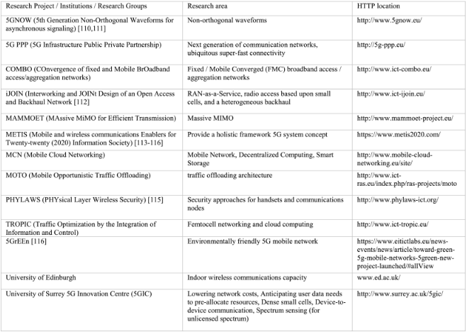

Table 4 - 5G related activities in Europe [24]

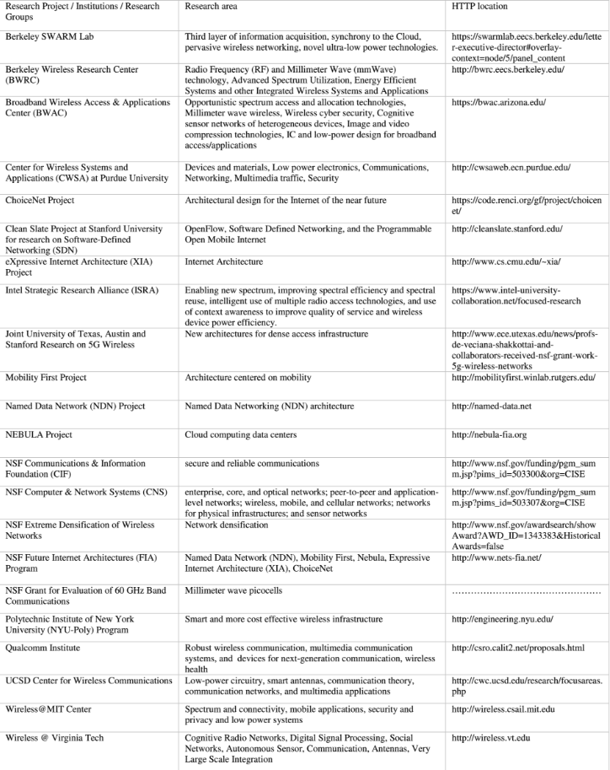

Table 5 - 5G related activities in America [24]

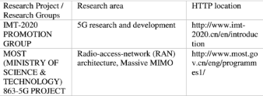

Table 6 - 5G related activities in Asia [24]

# Appendix B

4G VoLTE devices list in India

|  |  |  |
| --- | --- | --- |
| Number | Manufacturer | Model |
| 1 | Alcatel | Pop 3 |
| 2 | Alcatel | Pop 3 |
| 3 | Apple | iPhone 5 |
| 4 | Apple | iPhone 5S |
| 5 | Apple | iPhone 6 |
| 6 | Apple | iPhone 6S |
| 7 | Apple | iPhone 7 |
| 8 | Apple | iPhone 7S |
| 9 | Asus | Laser 5.0 (ZE500KL) |
| 10 | Asus | Zenfone Pegasus 3 |
| 11 | BlackBerry | Venice |
| 12 | Blackberry | Priv |
| 13 | Coolpad | Mega 2.5D |
| 14 | Coolpad | Note 5 |
| 15 | Coolpad | Note 3S |
| 16 | Coolpad | Mega 3 |
| 17 | Coolpad | Cool 1 |
| 18 | Gionee | S6 |
| 19 | Gionee | F103 |
| 20 | Gionee | P7 |
| 21 | Gionee | S9 |
| 22 | Gionee | P7 Max |
| 23 | Gionee | S6 Pro |
| 24 | Gionee | M2017 |
| 25 | Google | Pixel XL |
| 26 | Google | Pixel |
| 27 | HTC | One M9+ |
| 28 | HTC | One A9 |
| 29 | HTC | 10 |
| 30 | HTC | Desire 10 Lifestyle |
| 31 | HTC | Desire 10 Pro |
| 32 | HTC | U Ultra |
| 33 | HTC | U Play |
| 34 | Huawei | Honor 5A |
| 35 | Huawei | Enjoy 6S |
| 36 | Huawei | Honor 8 |
| 37 | Infocus | M370 I |
| 38 | Infocus | M808 I |
| 39 | Infocus | M535 |
| 40 | Intex | Aqua 4G |
| 41 | Intex | Aqua Ace Mini |
| 42 | Intex | Aqua ace 2 |
| 43 | Intex | Aqua Craze |
| 44 | Intex | Cloud Sting |
| 45 | Intex | Cloud String HD |
| 46 | Intex | Cloud string v2 |
| 47 | Intex | Aqua Music |
| 48 | Intex | Aqua S7 |
| 49 | Intex | Aqua Race 2 |
| 50 | Karbonn | Aura |
| 51 | Lava | A71 |
| 52 | Lava | 4G Connect M1 |
| 53 | Lenovo | Vibe Shot |
| 54 | Lenovo | Vibe P1 |
| 55 | Lenovo | A 6000 Plus |
| 56 | Lenovo | Z2 |
| 57 | Lenovo | Z2 Plus |
| 58 | Lenovo | A6600 |
| 59 | Lenovo | A6600 Plus |
| 60 | Lenovo | A7700 |
| 61 | Lenovo | Zuk Edge |
| 62 | Lenovo | Vibe P2 |
| 63 | Lenovo | K3 Note |
| 64 | LG | Nexus 5X |
| 65 | LG | Spirit 4G |
| 66 | LG | G3 4G LTE 32GB |
| 67 | LG | G4 |
| 68 | LG | G4 Stylus 4G |
| 69 | LG | M1DS |
| 70 | LG | K7 |
| 71 | LG | K10 |
| 72 | LG | X power 2 |
| 73 | LYF | water 1 |
| 74 | LYF | water 2 |
| 75 | LYF | water 3 |
| 76 | LYF | Earth 1 |
| 77 | Lyf | Flame 1 |
| 78 | Lyf | Flame 3 |
| 79 | Lyf | Flame 4 |
| 80 | Lyf | Water 1 |
| 81 | Lyf | Flame 2 |
| 82 | Lyf | Water 5 |
| 83 | Lyf | Wind 5 |
| 84 | Lyf | Flame 6 |
| 85 | Lyf | Water 8 |
| 86 | Lyf | Water 4 |
| 87 | Lyf | Wind 6 |
| 88 | Lyf | Flame 7 |
| 89 | Lyf | Wind 7 |
| 90 | Lyf | Flame 8 |
| 91 | Lyf | Wind 3 |
| 92 | LYF | F8 |
| 93 | LYF | Water 9 |
| 94 | LYF | F1 Plus |
| 95 | LYF | F1 |
| 96 | Lyf | F1S |
| 97 | Meizu | M5 |
| 98 | Meizu | M3S |
| 99 | Micromax | Canvas Amaze |
| 100 | Micromax | Juice 4G (Q461) |
| 101 | Micromax | Canvas Mega 4G |
| 102 | Micromax | Canvas Knight |
| 103 | Micromax | Canvas Silver 5 |
| 104 | Micromax | Vdeo 1 |
| 105 | Micromax | Vdeo 2 |
| 106 | Micromax | Canvas Spark 4G |
| 107 | Micromax | Dual 5 |
| 108 | Microsoft | All devices with and above 8.1 Supports VoLTE |
| 109 | Motorola | Moto E (2nd Gen) |
| 110 | Motorola | Moto G (3rd Gen) |
| 111 | Motorola | Moto G Turbo |
| 112 | Motorola | Moto X Play |
| 113 | Motorola | Moto G4 Plus |
| 114 | Motorola | E3 Power |
| 115 | Motorola | G4 Play |
| 116 | Motorola | M |
| 117 | Motorola | G5 Plus |
| 118 | Motorola | G5 |
| 119 | NOKIA | 5 |
| 120 | Nubia | N1 |
| 121 | Nubia | Z11 |
| 122 | One Plus | 1 Plus 2 |
| 123 | Oppo | Neo 7 |
| 124 | Oppo | S9 |
| 125 | Oppo | RS9 |
| 126 | Oppo | RS9 Plus |
| 127 | Oppo | F1 |
| 128 | Panasonic | Eluga Arc |
| 129 | Panasonic | Eluga A2 |
| 130 | Panasonic | Eluga Note |
| 131 | Panasonic | P 77 |
| 132 | Panasonic | Eluga Prime |
| 133 | Panasonic | P88 |
| 134 | Panasonic | Eluga Pulse X |
| 135 | Panasonic | Eluga Pulse |
| 136 | Samsung | Galaxy Core Prime 4G |
| 137 | Samsung | Galaxy A5 |
| 138 | Samsung | Galaxy A7 |
| 139 | Samsung | Galaxy A8 |
| 140 | Samsung | Galaxy S6 |
| 141 | Samsung | Galaxy S6 Egde |
| 142 | Samsung | Galaxy S6 Edge Plus |
| 143 | Samsung | Galaxy Note 4 |
| 144 | Samsung | Galaxy Note 5 |
| 145 | Samsung | Galaxy Note Edge |
| 146 | Samsung | Galaxy J5 |
| 147 | Samsung | Galaxy J7 |
| 148 | Samsung | Galaxy On5 |
| 149 | Samsung | Galaxy On7 |
| 150 | Samsung | Note 5 Duos |
| 151 | Samsung | J2 |
| 152 | Samsung | S7 |
| 153 | Samsung | S7 Edge |
| 154 | Samsung | C5 |
| 155 | Samsung | C7 |
| 156 | Samsung | Galaxy On5 Pro |
| 157 | Samsung | Galaxy On7 Pro |
| 158 | Samsung | Galaxy On 8 |
| 159 | Samsung | Galaxy C7 Pro |
| 160 | Samsung | S8 |
| 161 | Samsung | S8+ |
| 162 | Sony | Xperia Z5 Dual |
| 163 | Sony | Xperia Z5 Premium  Dual |
| 164 | Sony | XZs |
| 165 | Swipe | Elite sense |
| 166 | Swipe | Konnect Neo |
| 167 | TCL | 950 |
| 168 | Videocon | Krypton3 V50JG |
| 169 | Vivo | X33 |
| 170 | Vivo | X9 |
| 171 | Vivo | X9 Plus |
| 172 | Vivo | Y55s |
| 173 | Vivo | Y55L |
| 174 | Xiaomi | Redmi 2 Prime |
| 175 | Xiaomi | Note 3 |
| 176 | Xiaomi | Redmi 2 (2014818) |
| 177 | Xiaomi | Mi 5 |
| 178 | Xioami | Mi MAX |
| 179 | Xioami | Redmi 3S Plus |
| 180 | Yu | Yunique |
| 181 | Yu | Yuphoria |
| 182 | Yu | Yureka Plus |
| 183 | Yu | Note (YU6000) |
| 184 | Yu | Yureka 3 (YU5200) |
| 185 | Yu | Yutopia (YU5050) |
| 186 | ZTE | Blade S6 |
| 187 | ZTE | Blade S6 Plus |

Table - 4G VoLTE devices list in India - updated at 09-04-2017 [41]